Before seeing go through this: https://chatgpt.com/c/6a1c0c5d-296c-83e8-8bf0-1d4ad2a9f9d7

When we talk about quantization we specifically mean LLM quantization.
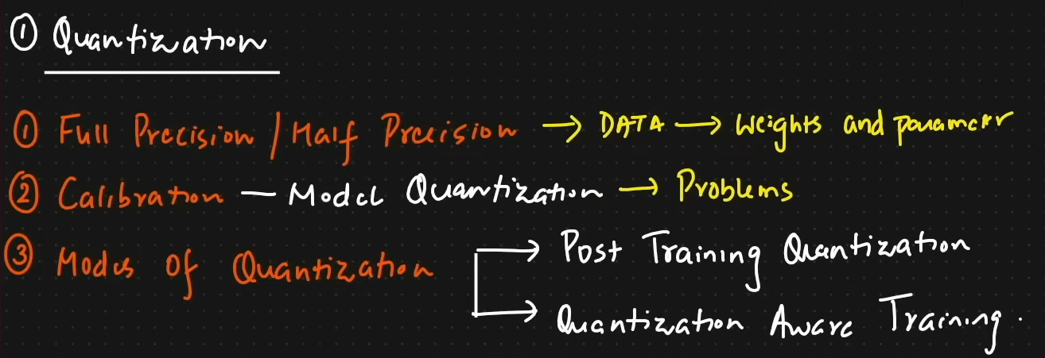
Quantization: It basically means conversion from higher memory format to a lower memory format. What is this format we are talking about. In a neural network we have weights and suppose if it is stored in a matrix of 3X3, as 7.23 based on a FP 32 Bit format in memory where FP is full precision. And now suppose we have a very big neural network or an LLM, the parameters are very large some may have 70 bil parameters. Now it is not possible for us to download the model in order to fine tune it because of our limitations in GPU and very less RAM. So what can be done is we can convert 32 bit into int 8 format and inference it.
LLMs are huge, a 7B parameter model in FP16 needs roughly 14GB memory if it is quantized to 4-bit it will become 3.5GB memory. Its like a raw image converted into a compressed jpg image. FP 16 is Half precision since FP is full precision.

Now lets talk about what is Calibration:
It is basically how can we do this conversion. There are two types of quantization 1. Symmetric Quantization 2. Asymmetric Quantization.
Using calibration we can map floating-point values into integer values.
Modes of Quantization: Post Training Quantization and Quantization Aware Training
Post Training Quantization (PTQ) – Here we already have a pretrained model. After applying calibration and taking weight’s data then we convert the llm into quantized model. After which we can use the model for any suitcases.
Quantization Aware Training (QAT) - Model trains while simulating quantization. The model “learns to survive” low precision.
Advantages:
- better accuracy
Disadvantages:
- harder and expensive training

